S

Title: Word document template
Subtitle
Konrad Muster

Abstract

Heading 1

Heading 2

Heading 3

Heading 4

Format: Body text
The paper template contains its own Format with styles for formatting the subject. Open the bar for the styles using Alt + Ctrl + Shift +S.
Use the Body Text Style for ordinary text paragraphs like these.
Automatic Hyphenation is activated.

Lists/Bullets
Use the list style for regular text paragraphs like this.
- first
- second
- third

Numbering
- Firstly,
- Second,
- Third,

Pictures and Tables
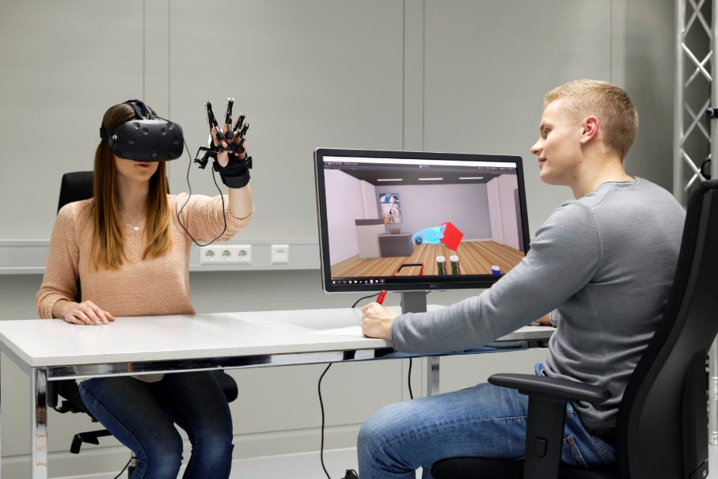
Figure 4: Example of a caption in "Caption" format
Hazard Class | A 1 to A III
Flash point | < 21 °C / > 55 °C
Density at 15 °C | 720 kg/m³ to 860 kg/m³
Kinematic Viscosity | 0,65 to 4,0 x 10^{–6} m²/s
Table 1: Example of a table signature in the "Caption" format

References
References according to IEEE Standard
- In text, references should be cited on the line, in square brackets, inside the punctuation, e.g.:

… as shown by Yan et al. [2], …as mentioned earlier [1], [3], [9];

- Basic format:
[1] J. K. Author, “Name of paper,” Abbrev. Title of Journal, vol. x, no. x, pp. xxx-xxx, Abbrev. Month, year, doi: xxx.

- Examples:
[2] K. Yan, Z. Ji and W. Shen, "Online fault detection methods for chillers combining extended kalman filter and recursive one-class SVM", Neurocomputing, vol. 228, pp. 205-212, 2017. doi: 10.1016/j.neucom.2016.09.076
[3] S. Preu, G.H.Döhler, S.Malzer, L.J.Wang, and A. C. Gossard,“Tunable continuous-wave terahertz photo mixer sources and applications,” J. Appl. Phys., vol. 109, Mar. 2011, Art. no. 061301.

-----------------------------------------------------------------------------------------------------------------------------

Insert text and pictures of your lecture here.
Insert text and pictures of your lecture here.
Insert text and pictures of your lecture here.

You can create your technical contribution directly in the template. Make a copy of the template beforehand for safety. This file is pre-formatted, please only use these styles!
Tip: under Options: set "used styles" and you will only be shown the required formats.
Please do not use page numbers and headers / footers!
For images and tables, please use the "Text / Image / Table" format template, for body text "Body Text ".
Please do not insert images via clipboard. First, in the image source application (e.g. your image editing program) Save in TIFF, EPS or JPEG format. Then insert the previously saved image file via the menu item "Insert> Picture> From a file ...".
Press the <Return> to set the “Label” paragraph format for the next paragraph.
Since the pages are reduced to A5 before printing, very good print reproduction is achieved if you save graphics with a resolution of 450 dpi and photos with a resolution of at least 250 dpi.

BSc Eng. Konrad Muster, Example GmbH, Stadthausen

